<https://mamonivalleypreserve.org/>

lo que es: https://mamonivalleypreserve.org/the-preserve/

WILD Campo Alegre  
**The WILD Campo Alegre Nature Reserve (WCA) is located at 3100-3300 m. in the central mountain range “Cordillera central” in Colombia, some 25 kilometers East of Pereira. Adjacent to some of the last remaining high cloud forest, it is an extremely important reserve for conserving and restoring the cloud forests and very important species such as Mountain Tapir and the Fuertes Parrot.**  
(este parte arriba va dentro de la foto)  
  
The nature reserve was established in January 2023 when the two cattle farms or “fincas” Cortaderal and Aurora were bought from a local land owner. The area is at around 3100 meters above sea level and borders with the last remaining cloud forests that still contains very important biodiversity and all the important large fauna, including mountain tapir, spectacled bear, puma and at least two other species of felines. Also a number of endemic birds inhabit the area, most famously the Fuertes parrot. It encompasses some 731,6 hectares of which 55% is primary and secondary forest and 45% are former pastures. The last cattle was removed at the end of April 2023 and during 2023 more than 200.000 seedlings of native tree species have been planted in WCA.  
The aim of the project is to conserve and restore these important cloud forest habitats and to expand the project to at least 2000 hectares, and hopefully much more. Also, WCA will be a centre for research inviting biologist, students etc. to conduct fieldwork in the area and make use of our field station.  
The expansion of the reserve can be done in many different ways, by collaborating with local authorities, that have also purchased fincas, or large local land owners, or by buying up more land.

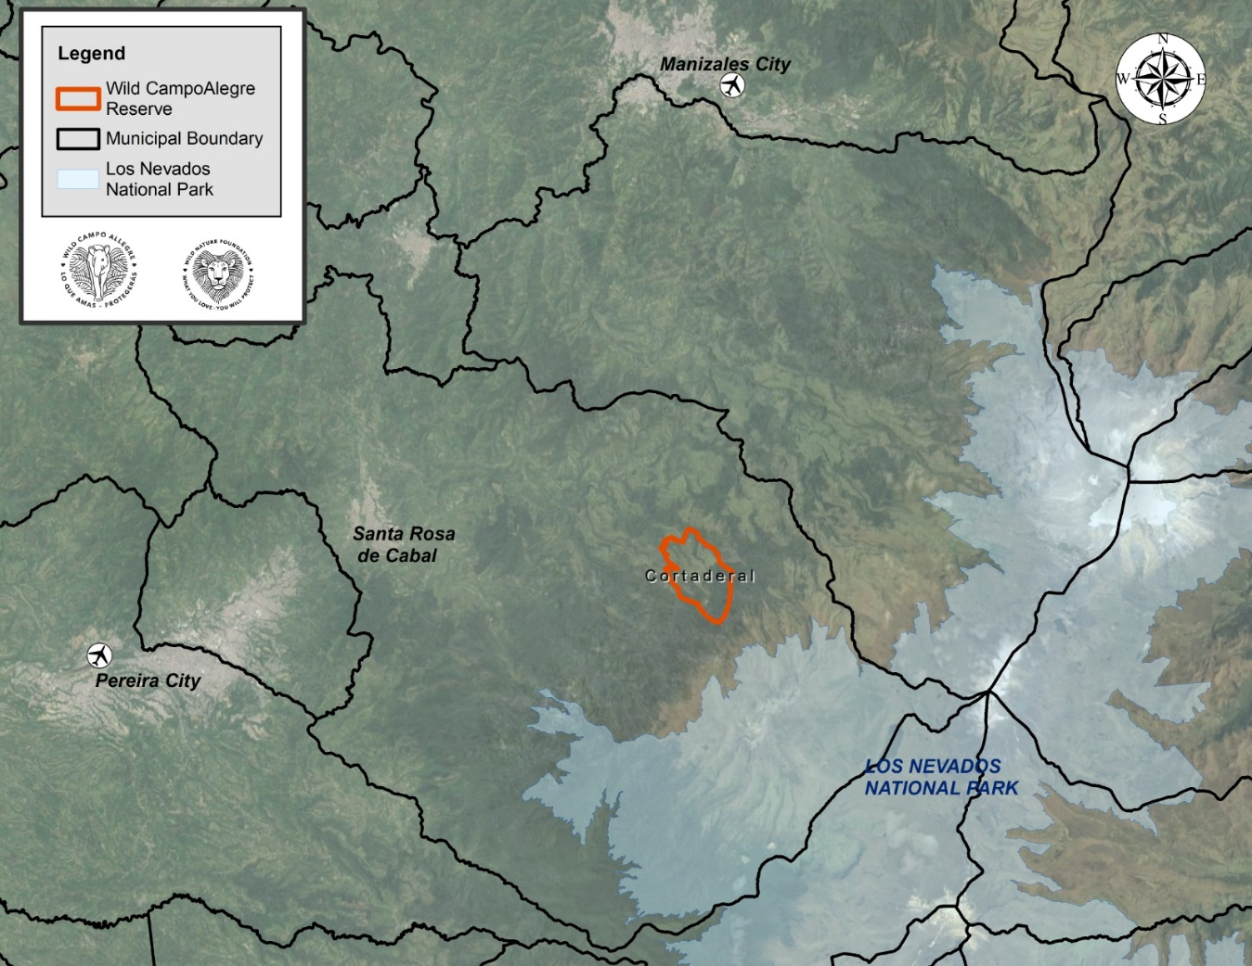

<https://mamonivalleypreserve.org/the-preserve/the-mamoni-valley/>

Distrito de Conservación de Suelos Campoalegre DCSC

DCSC is a protected área in which WILD Campo Alegre is situated. DCSC covers more that 20.000 hectares and although most of this area is cattle farms, strict rules apply, and it is illegal to cut down forest and many initiatives are being implemented to further protect the area. The local environmental authorities CARDER is managing the area and WILD Campo Alegre has an excellent cooperation with CARDER.   
This close cooperation is in the best interest of both and has secured and will in the future further secure, that more of the unique cloud forest will be protected and restored.  
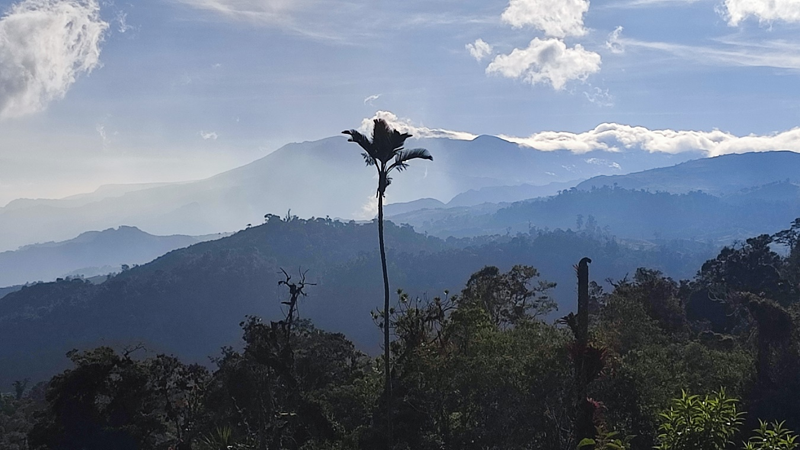

https://mamonivalleypreserve.org/the-preserve/biodiversity/

**Biodiversity**

Although the entire area was once heavily forested, large areas of forest have been cleared for cattle pasture. WILD Campo Alegre has begun the important work of recovering large sections of deforested land as they slowly return to their prior forested state. WCA also includes tracts of original primary forest, which are crucial sources of the plants, animals, fungi, and microbes that will allow deforested sections to recover.

Central to this recovery are WCA’s tracts of original primary forest, which serve as vital reservoirs of biodiversity. These areas are crucial for supplying the plants, animals, fungi, and microbes necessary to facilitate the natural regeneration of the deforested lands. As the vegetation reclaims its rightful place, these lush forests showcase the power of natural restoration in maintaining the ecological balance and enhancing the biodiversity of the region.

The cloud forest in WCA is home to a wide variety of mammals, including the endangered and very rare mountain tapir, spectacled bear, red brocket deer, puma, ocelot and tiger cat. The preserve also shelters a rich diversity of bird species, reptiles, amphibians, and insects. Among its most unique inhabitants is the Fuertes Parrot, that is almost entirely confined to this small area in Colombia.

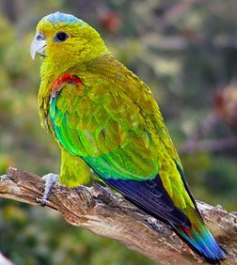By preserving this precious ecosystem, we not only maintain the delicate balance of the region’s flora and fauna but also ensure that future generations can marvel at the wonders of the cloud forest. This ongoing conservation effort highlights the importance of biodiversity in protecting such ecological corridors, which are essential for the survival of many species and the health of our planet.